**Arithmetic Comparison**

1) Write a program to demonstrate the use of not equal to operator.

Hint: -ne

Arth.sh

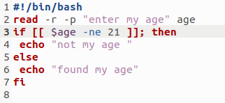

Terminal

